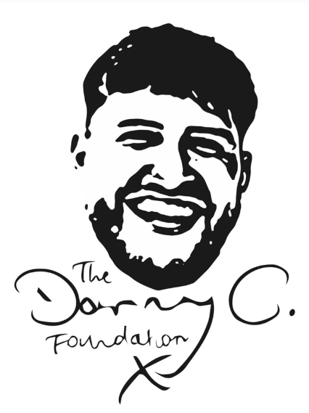
The Danny C. Foundation personal grant application form:

Grant recipient details
Name
Address
Contact number
Email address
DOB
Gender
Ethnicity
Occupation and hours
First language
Any support services currently under
Any known risks, license conditions/exclusions zones (if on probation)
Any disabilities, learning difficulties or accessibility concerns?
Do you consent to this application being made?
Do you consent to being contacted by The Danny C. Foundation?

Applicant supporter details (e.g. parent, teacher, probation officer, social worker etc.)
Date of application
Name
Address
Contact number
Email address
Relationship to grant recipient
Do you consent to being contacted by The Danny C. Foundation?

Grant details
Is your grant relevant to…  (please tick) | - A block of sport sessions, gym membership or 1-1 personal training.  - Sponsorship to join a local sports or community club with a positive environment.  - A block of private therapy as opposed to being on a long NHS waiting list.  - A block of private life-coaching sessions.  - An adult course, training or relevant tools/equipment that will contribute to potential employment.  - Financial relief for basic needs so that an individual does not need to return to crime for funds.  - Other.
In as much detail as you can, please provide a description of:

- The recipient’s current situation e.g. their current or potential involvement in knife crime, any mental health issues, financial worries, family concerns, struggles with school etc.
- The kind of grant they are looking for, either one that is listed or another request relevant to reducing their knife crime offending.
- How the grant will specifically be used e.g. I am looking for a grant for a block of eight boxing sessions, as due to financial concerns I would not be able to fund this myself, but I feel this would give me an outlet to vent my frustrations in a positive way, improve my current negative state of mental health and stop me getting involved in unhealthy and risky behaviours.

Consent
I declare that the information I have provided in this form is truthful to the best of my knowledge.
I understand that my personal grant may not be accepted if my application is not applicable.
Should my grant be accepted, I am happy to draw up and sign a contract that outlines the terms and conditions relevant to appropriate use of my grant.

Grant recipient signature: ___________________

Applicant supporter signature: _______________

Please send your completed form to chloec@dannycfoundation.org.uk. If you would like to discuss any parts of your application, please do not hesitate to include a phone call request on your email and you will be contacted as soon as possible. Thank you for your application!

