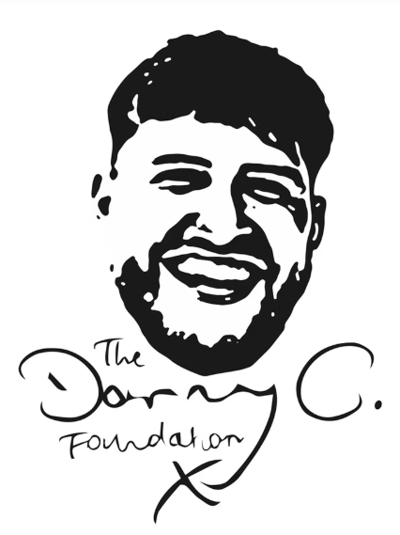
The Danny C. Foundation personal grant application form:

Grant recipient details
Name
Address
Contact number
Email address
DOB
Gender
Ethnicity
Occupation and hours
First language
Any support services currently under
Any known risks, license conditions/exclusions zones (if on probation)
Any disabilities, learning difficulties or accessibility concerns?
Do you consent to this application being made?
Do you consent to being contacted by The Danny C. Foundation?

Applicant supporter details (e.g. parent, teacher, probation officer, social worker etc.)
Date of application
Name
Address
Contact number
Email address
Relationship to grant recipient
Do you consent to being contacted by The Danny C. Foundation?

About you
We believe in taking a holistic approach, and will use all of the following information to tailor the best grants to your needs and improve your life as a whole. We can also advise or signpost you to other organisations that may be able to provide further help, and advise on the best education resources to use, so please provide as much detail as you can on areas that are causing you issues, especially if there are linked to knife crime offending.
Tell us about your future aspirations related to education or work: e.g. are you currently working, out of work, wanting to return to work, still in education, wanting to return to education etc.

Tell us about any of your social connections: e.g. your family situation, your friends, any other social circles, relationships, are you a parent etc.

Tell us about your mental health and emotional wellbeing: e.g. are you struggling with any mental illness, have you been diagnosed or suspect you should be diagnosed, are you managing your emotions well, do you have confidence or good self-esteem etc.

Tell us about your physical health and wellbeing: are you active, eating well, managing any physical conditions or disabilities etc.

Tell us about your living situation: e.g. are you happy with your current accommodation, is it causing you any problems, do you feel safe where you live etc.

Tell us about any unhealthy habits or hobbies you have: e.g. smoking, drinking, using substances, misusing the internet etc.

Tell us about your financial situation: e.g. do you feel like you are managing your money well, can you prioritise and budget funds, do you have enough for basic needs etc.

Grant details
Is your grant relevant to…  (please tick) | - A block of sport sessions, gym membership or 1-1 personal training.  - Sponsorship to join a local sports or community club with a positive environment.  - A block of private therapy as opposed to being on a long NHS waiting list.  - A block of private life-coaching sessions.  - An adult course, training or relevant tools/equipment that will contribute to potential employment.  - Financial relief for basic needs so that an individual does not need to return to crime for funds.  - Other.
In as much detail as you can, please provide a description of:

- The kind of grant they are looking for, either one that is listed or another request relevant to reducing their knife crime offending.
- How the grant will specifically be used e.g. I am looking for a grant for a block of eight boxing sessions, as due to financial concerns I would not be able to fund this myself, but I feel this would give me an outlet to vent my frustrations in a positive way, improve my current negative state of mental health and stop me getting involved in unhealthy and risky behaviours.

Consent
I declare that the information I have provided in this form is truthful to the best of my knowledge.
I understand that my personal grant may not be accepted if my application is not applicable.
Should my grant be accepted, I am happy to draw up and sign a contract that outlines the terms and conditions relevant to appropriate use of my grant.

Grant recipient signature: ___________________

Applicant supporter signature: _______________

Please send your completed form to chloec@dannycfoundation.org.uk. If you would like to discuss any parts of your application, please do not hesitate to include a phone call request on your email and you will be contacted as soon as possible. Thank you for your application!

